1. From the home page of your SharePoint site, open any list or library you would like, in this example I will open my "**Documents**" library.

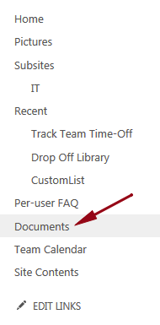

2. At the top of the page click **Library** to expand the ribbon.

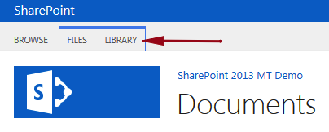

3. In the Settings section on the far right click **Library Settings**.

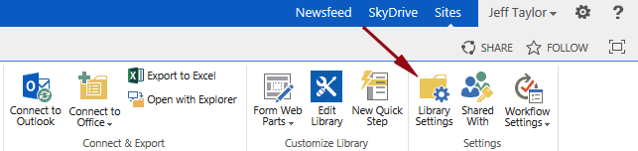

4. Scroll down to the columns section and click on the column you want to modify, in this example I will click on the "**Purpose**" column.

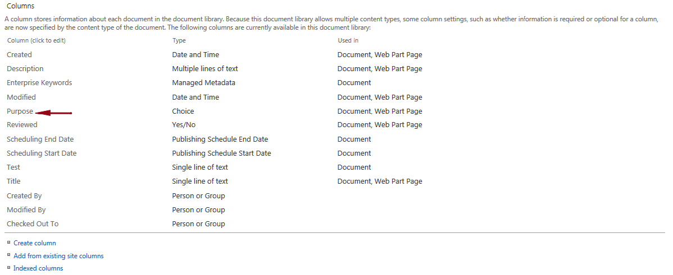

5. The column can now be modified but first make note of the other settings you can update; I will add an additional choice called “**Internal**”.

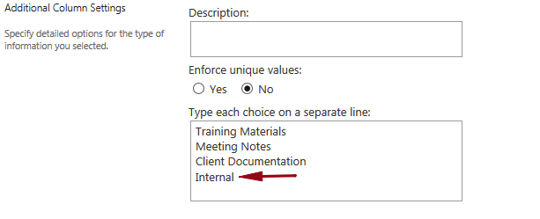

6. Click **OK**.  
  
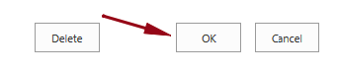  
You have now modified an existing column.